SCHOOL OF INDIA, K.R. PET

HOBBY CLASS REPORT 2026-27

Std: VII A Date: 09/7/2026

- Activity: Book markermakingactivity
- Activity Conducted Photo:
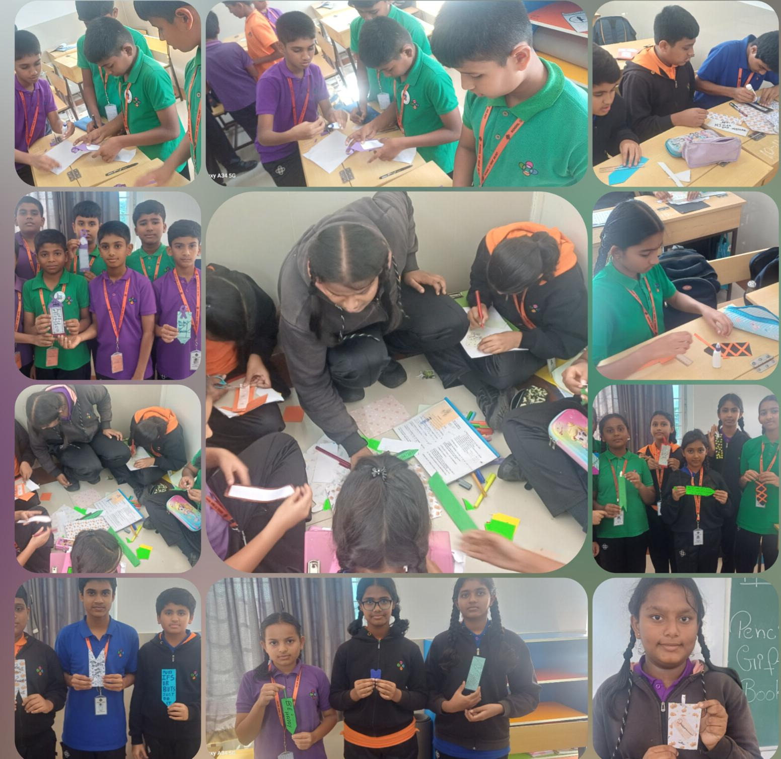
3. Number of students: 29.

Signature of Teacher In Charge:Athar Jahan

